TEST SUMMARY REPORT

SIT Testing Phase

Project Dataglow Release 1

|  |  |
| --- | --- |
| **Project Sponsor** | Gabrielle Shone |
| **Business Unit** | Customer Markets |
| **Initiative Name** | Project Dataglow |
| **Document Version** | 1.1 |
| **Document Classification** | For Approval |

**Last updated:** 17/05/2019

**Document Control**

|  |  |  |  |  |
| --- | --- | --- | --- | --- |
| **Version** | **Date** | **Authors** | **Section** | **Nature of Amendment** |
| 0.2 | 13/05/2019 | Test Team | All | Initial Version for Walkthrough & Review |
| 1.0 | 14/05/2019 | Test Team | Sec 3 & 4 | End to End Testing Updates |
| 1.1 | 16/05/2019 | Test Team | Sec 3 & 4 | End to End Updates & Pipeline Execution Timings (For Reference) |

**References**

|  |  |  |
| --- | --- | --- |
| **Document Name** | **Version** | **Author** |
| Solution Architecture Document | [Confluence](https://aglenergy.atlassian.net/wiki/spaces/AD/pages/525828887/Cross+Sell+Win+Back) | Solution Arch Team |
| Source to Target Mapping Document | [SharePoint](https://teams.microsoft.com/_#/files/General?threadId=19%3Aebd6d66043954648861bbb564ac9cee7%40thread.skype&ctx=channel&context=3.0%2520Source%2520to%2520Target%2520Mapping) | Data Modelling/Analyst Team |

Table of Contents

1. Document & Test Scope Overview 4

2. Executive Summary 5

3. SIT Overview 6

3.1. Test Coverage 6

3.2. Risks & Issues – Raised & Closed 7

3.3. Open Items and Next Steps 8

4. SIT Test Result 9

4.1. Test Results Summary 9

4.2. Pipeline Timings – Initial & Delta Loads (For Reference) 10

4.3. Closed Defects Summary 10

4.4. Exit Criteria 11

4.5. Conclusion 11

1. Document & Test Scope Overview

|  |  |
| --- | --- |
| Document Overview | |
| Purpose | The purpose of this document is as follows:   * To provide overview of test coverage during SIT Phase including End to End for Dataglow Initiative around data testing from Source to Raw Data Vault * To share associated test results * To share the outstanding defects and their statuses * Provide defect summary of closed defects found during test execution * Provide details of risks/issues raised/closed during test execution * Provide overview of Testing Outcome and recommendation |
| Scope | * Data Testing till Staging – Typing & Loading:   + New DS Jobs (Source – CSV – PQT - STG)   + SAP Sources with existing DS Job – Delta Files (CSV – PQT – STG)   + Non-SAP Sources with existing DS Job – Delta Files (CSV – PQT – STG)      * Data Testing for Raw Vault   + Initial Load (SAP Day-0) – Staging –> Hubs, Links, Satellites   + Delta Load (SAP & Non-SAP Sources) – Staging -> Hubs, Links, Satellites, Tlinks * Exception/Failure Scenarios   + New DS to CSV Extraction, Typing, Loading, Data Vault – Hubs, Links, Satellites * End to End Testing   + SAP Sources   + Non-SAP Sources |

1. Executive Summary

|  |  |
| --- | --- |
| Executive Overview | |
| Project | Project Dataglow – Release 1 |
| Test Phase | SIT & End to End (Source to Raw Vault) |
| Test Environment | DEV – New DS to CSV, Typing & Loading – Including Typing/Loading Pipelines  TEST – Data Vault – Hubs, Links, Satellites & Typing/Loading Pipelines |
| Test Results Location | Jira Zephyr Based Test Execution  **Jira URL:** https://aglenergy.atlassian.net  **Jira Project:** Enterprise Data & Decisioning Platform  **Test Summary:** <https://aglenergy.atlassian.net/projects/EN?selectedItem=com.thed.zephyr.je__project-centric-view-tests-page&testsTab=test-cycles-tab>  SharePoint Location:  <https://aglenergy.sharepoint.com/:f:/r/teams/FileTransfer/Shared%20Documents/General/7.0%20Testing/Test%20Results?csf=1&e=LUyUO8> |
| Defects Location | **Jira URL:** https://aglenergy.atlassian.net  **Jira Project:** Enterprise Data & Decisioning Platform  Location of Defects: <https://aglenergy.atlassian.net/issues/?filter=46792> |
| Test Period | * Delta Data – Typing & Loading – 11-Apr – 30-Apr * New DS – 17-Apr – 10-May * Raw Data Vault – 01-May – 11-May * E2E Testing (Source to Raw Vault) – 06-May – 15-May |

1. SIT Overview
   1. Test Coverage

SIT Data Testing around the following areas:

* Data Testing till Staging – Typing & Loading:
  + New DS Jobs (Source – CSV – PQT - STG)
  + SAP Sources with existing DS Job – Delta Files (CSV – PQT – STG)
  + Non-SAP Sources with existing DS Job – Delta Files (CSV – PQT – STG)
* Data Testing for Raw Vault
  + Initial Load (SAP Day-0) – Staging –> Hubs, Links, Satellites
  + Delta Load (SAP & Non-SAP Sources) – Staging -> Hubs, Links, Satellites, Tlinks
* Exception/Failure Scenarios
  + New DS- CSV Extraction, Typing, Loading, Data Vault – Hubs, Links, Satellites
* End to End Testing
  + SAP Sources
  + Non-SAP Sources

Solution components included:

* Data Sources – SAP – CRM, SAP – ISU, HANA, GEEK, MDH, Unica
* Data Ingestion – SAP LT & DS, Non-SAP – SAP-DS
* Data Typing (CSV-PQT) & Loading (PQT-SQL DW STG & Raw Vault)
  + Azure Data Factory for Orchestration
    - Day-0 Pipelines
    - Delta Load (Control, DataLake, SQL DW Pipelines)
  + Azure Data Bricks for Processing
    - Metadata, SQL Validation, SQL Error, PQT File Generation
  + Azure SQL DW
    - PQT to STG Load Stored Procedures
    - STG to Hub/Links/Satellites Stores Procedures
  1. Risks & Issues – Raised & Closed

Risks & Issues raised during testing phase are indicated below. All of them has been closed and there are no outstanding bugs:

|  |  |  |  |  |
| --- | --- | --- | --- | --- |
| Date  Raised | Risk/Issue | Additional Details/  Closure Comments | Mitigation | Status |
| 06-May | Testing of “Source to Raw Vault” in TEST environment and “Business Vault / Information Mart / Use Case Extracts” in different DEV environment carries a risk of absence of System Integration Testing/End to End Source to Use Case Extracts for Go Live. | Due to constraints highlighted earlier including timelines and Business Vault/Information Mart and Use Case Extracts solution being in design/dev phased, solution components beyond Raw Vault are being tested by data modelling/engineering team members who did not participate in build | No mitigation – Risk to be accepted by Stakeholders  Discussed & Closed | Closed |
| 06-May | High Defect Density and Associated Fixes may have impact on already tested scenarios – thus Regression Impact is likely | Currently there is no separate regression testing cycle. Code Changes made due to changing source to target mapping and defect fixes may result in issues  Update (10/5) – 100% SAP/Non-SAP Delta Testing done | Delta Testing Phase to have additional coverage of all SAP Files/Tables along with the planned Non-SAP items to mitigate this risk. This phase covers all pipelines as well. | Closed |
| 2-May | More than 50% of Data Vault pipelines failures has been reported. Significant effort for rerunning pipelines, time taken for initial data to load again and re-executing the test cases | Pipelines are being executed by test team which loads the data in the target tables. Test Validation of Data Vault occurs after successful load of data. This time was not anticipated and may result in schedule slippage  Update (8/5) – No outstanding pipeline related failures and Daily Test Progress Updates | Daily Status updates on open items and impact to timelines. Delivery Team to take a call on open issues and any end date impacts | Closed |
| 1-May | End to end testing relied upon having SAP Prod Access for test team which has been advised as a challenge | This phase involved sample-based checks between Sources and Data Vault and will therefore require source system access  Update (7/5) – Subhrajit provided the required SAP extracts | Ratish provided an alternate approach of verification based on source extracts. | Closed |
| 23-Apr | Downstream components - Business Vault, Information Mart, Use Case related extracts is in design/build phases – Test Execution of these components will be a challenge as per current timelines | Update (1/5): These solution components will be tested by the data modelling/ engineering/dev team not involved in coding phase | Current discussion is for Design/Dev Team to perform more detailed unit/system testing of these components to minimise additional testing required | Closed |
| 18-Apr | Test Execution Timeline for Data Vault Testing is very less as the start date slipped (~ 8 working days) and does not cater for unforeseen issues/defects/delays | Update (1/5) – Ratish actively guiding and assisting test team/overall testing and Mahesh to help with end to end testing phase. Test Approach revised and plan revised to complete accordingly | Initial Mitigation - Data Engineer will assist with stored procedures to speed up the execution - wherever possible. Prioritisation of tests/tables will be discussed towards enough risk-based coverage. No further changes to requirements/mapping document | Closed |
| 17-Apr | Testing not covering correctness of generated JSON Files used for typing and related testing. Incorrect JSON files will have follow-on impacts  Note: Probability of this issue occurring is low as existing methods of generating JSON files is being used | Testing covers data count and data value checks between source and target. Metadata check between CSV and Parquet uses JSON generated by Dev (Validation of this JSON was not considered as in-scope for testing)  Update (1/5) – End to end phase will cover off this risk and team to work on JSON validation in the longer term | Samples based checks across all tables from Source Systems to Data Vault will be done as part of End to End Testing. Source Systems access has been requested. Retests done for test scenarios executed with old source files with newer files from 2019. SAP Tables JSON Files being reviewed against DDL. | Closed |

* 1. Open Items and Next Steps

|  |  |  |  |
| --- | --- | --- | --- |
| Ref # | Description | Current Status | Next Steps |
| EN-962 | Padding Related Observations during E2E  (Common story covering 21 bugs) | These have been discussed and cannot be part of initial release. | To be taken up Post Go-Live |
| EN-746 | Pipeline processed data and created Parquet file even though CSV file naming convention is different from agreed | Advised that this is working as per design – Deprioritised and assigned to Scrum Master for next steps | To be taken up Post Go-Live |

**Note**: Above excludes defects raised as part of Information Mart Testing

1. SIT Test Result
   1. Test Results Summary

|  |  |  |  |  |  |  |  |
| --- | --- | --- | --- | --- | --- | --- | --- |
| **Test Cycle** | **Test Area** | **Total TC** | **Executed** | **Passed** | **% Executed** | **% Passed** | **Remarks** |
| **Initial Delta Load till Staging** | Typing/Loading Pipelines | 59 | 59 | 59 | 100% | 100% | Execution of Typing/Loading Pipelines  New Sources to CSV (Geek-7; Hana-2; MDH-2; Unica: 9)  Source Unica AGL_DNCR_HIST Descoped  Code Coverage – 100 % |
| New Sources to CSV | 18 | 18 | 18 | 100% | 100% |
| CSV to SQL DW Staging (SAP) | 72 | 72 | 72 | 100% | 100% |
| CSV to SQL DW Staging (Non-SAP) | 46 | 46 | 46 | 100% | 100% |
| **Initial Day-0 Load (Staging-Data Vault)** | Pipelines (SAP) | 36 | 36 | 36 | 100% | 100% | Execution of Loading & Data Vault Pipelines  SAP Data Load from Paquet to Staging and Staging to Data Vault (Hubs, Links, Satellites)  Code Coverage – 100 % |
| Hubs | 42 | 42 | 42 | 100% | 100% |
| Links | 35 | 35 | 35 | 100% | 100% |
| Satellites | 36 | 36 | 36 | 100% | 100% |
| **Delta Load (CSV- Data Vault)** | Pipelines (All) | 59 | 59 | 59 | 100% | 100% | Execution of Loading & Data Vault Pipelines  Non-SAP Data Load from CSV to Parquet; Parquet to Staging and Staging to Data Vault (Hubs, Links, Satellites)  Data Vault components - link_DNCR_History & sat_UNICA_DNCR_History descoped - As Unica AGL_DNCR_HIST not in scope  Code Coverage – 100 % |
| Failed Pipelines | NA |  |  |  |  |
| SAP (All) |  |  |  |  |  |
| Hubs | 42 | 42 | 42 | 100% | 100% |
| Links | 35 | 35 | 35 | 100% | 100% |
| Satellites | 36 | 36 | 36 | 100% | 100% |
| Non-SAP |  |  |  |  |  |
| Hubs | 34 | 34 | 34 | 100% | 100% |
| Links | 18 | 18 | 18 | 100% | 100% |
| Tlinks | 4 | 4 | 4 | 100% | 100% |
| Satellites | 14 | 14 | 14 | 100% | 100% |
| **End to End Testing (Source Extract – Data Vault)** | Failure Scenarios | 8 | 8 | 8 | 100% | 100% | Failure Testing Scenarios covered as part of test execution  End to End Approach - Subset of records uniquely identified by business keys retrieved from "Source of Truth" and matched against equivalent dataset build from the respective Hub/Sat/Link tables |
| SAP – ISU/CRM | 36 | 36 | 36 | 100% | 100% |
| HANA | 2 | 2 | 2 | 100% | 100% |
| UNICA | 10 | 10 | 10 | 100% | 100% |
| GEEK | 2 | 2 | 2 | 100% | 100% |
| MDH | 2 | 2 | 2 | 100% | 100% |

* 1. Pipeline Timings – Initial & Delta Loads (For Reference)



* 1. Closed Defects Summary

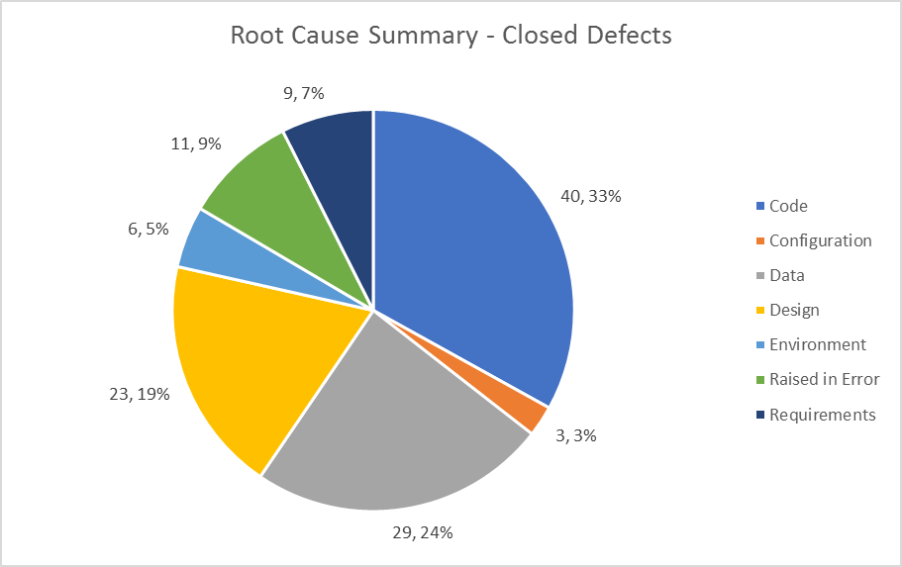



* 1. Exit Criteria

|  |  |
| --- | --- |
| Criteria Description | Status |
| New/Updates DS Jobs  (Source to CSV) | Completed |
| Pipeline Execution – CSV-Parquet, Parquet to SQL DW Staging, SQL DW Staging to Data Vault | Completed |
| Typing & Loading Scenarios – Delta Files (SAP & Non-SAP) from CSV to SQL DW Staging | Completed |
| Initial Day-0 Load Scenarios (SAP Sources) – SQL DW Staging to Data Vault (Hubs, Links, Satellites) | Completed |
| Delta Load Scenarios (Non-SAP & SAP Sources) – SQL DW Staging to Data Vault (Hubs, Links, Satellites, Tlinks) | Completed |
| Failure & End to End (Source to Raw Vault) Test Cases | Completed |
| All defects (Blocker, Critical, Major) resolved and closed  *Excludes any Information Mart Testing Defects | Completed |
| Open Defects (Minor, Trivial) – Action Plan – Refer Section 3.3  *Excludes any Information Mart Testing Defects | Completed |

**Note:** Business Vault, Information Mart & Use Case Extracts from Information Mart is not in scope of this document

* 1. Conclusion

For the test areas covered as part of this document and based on the exit criteria mentioned above, the associated changes are suggested to ‘Go-Live’.

Test Coverage of Business Vault, Information Mart & Use Case Extracts and UAT Approval of the use case extracts should complete before Go-Live. Separate test result document will cover these areas.